INTRODUCTORY RITES
Entrance Antiphon 1 Pt 2: 2
Like newborn infants, long for the pure, spiritual milk,
that in him you may grow to salvation, alleluia.
The Priest and the faithful, standing, sign themselves with the Sign of the Cross, while the Priest, facing the people, says:
In the name of the Father, and of the Son, and of the Holy Spirit.
The people reply:
Amen.
Then the Priest, extending his hands, greets the people, saying:
The grace of our Lord Jesus Christ,
and the love of God,
and the communion of the Holy Spirit
be with you all.
The people reply:
And with your spirit.

Penitential Act
The Priest invites the faithful, saying:
Brothers and sisters, let us acknowledge our sins,
and so prepare ourselves to celebrate the sacred mysteries.
A brief pause for silence follows. Then all recite together the formula of general confession:
Priest:
You were sent to heal the contrite of heart. Lord, have mercy.
The people reply:
Lord, have mercy.
The Priest:
You came to call sinners. Christ, have mercy.
The people:
Christ, have mercy.

The Priest:
You are seated at the right hand of the Father to intercede for us. Lord, have mercy.
The people:
Lord, have mercy.
The absolution by the Priest follows:
May almighty God have mercy on us,
forgive us our sins,
and bring us to everlasting life.
The people reply:
Amen.

Gloria
The Gloria in excelsis (Glory to God in the highest) is said.

Collect (Opening Prayer)
The Priest, with hands joined, says:
Let us pray.
And all pray in silence with the Priest for a while.
Then the Priest, with hands extended, says the Collect prayer:
God of everlasting mercy,
who in the very recurrence of the paschal feast
kindle the faith of the people you have made your own,
increase, we pray, the grace you have bestowed,
that all may grasp and rightly understand
in what font they have been washed,
by whose Spirit they have been reborn,
by whose Blood they have been redeemed.
Through our Lord Jesus Christ, your Son,
who lives and reigns with you in the unity of the Holy Spirit,
one God, for ever and ever.
The people acclaim:
Amen.

THE LITURGY OF THE WORD
First Reading Acts 2:42-47
All who believed were together and had all things in common.
A reading from the Acts of the Apostles
They devoted themselves
to the teaching of the apostles and to the communal life,
to the breaking of bread and to the prayers.
Awe came upon everyone,
and many wonders and signs were done through the apostles.
All who believed were together and had all things in common;
they would sell their property and possessions
and divide them among all according to each one’s need.
Every day they devoted themselves
to meeting together in the temple area
and to breaking bread in their homes.
They ate their meals with exultation and sincerity of heart,
praising God and enjoying favor with all the people.
And every day the Lord added to their number those who were being saved.
To indicate the end of the reading, the reader acclaims:
The word of the Lord.
All reply:
Thanks be to God.

Responsorial Psalm Ps 118:2-4, 13-15, 22-24
Response: Give thanks to the Lord, for he is good, his love is everlasting.
Let the house of Israel say, “His mercy endures forever.”
Let the house of Aaron say, “His mercy endures forever.”
Let those who fear the LORD say, “His mercy endures forever.”
Response: Give thanks to the Lord, for he is good, his love is everlasting.
I was hard pressed and was falling, but the LORD helped me.
My strength and my courage is the LORD, and he has been my savior.
The joyful shout of victory in the tents of the just:
Response: Give thanks to the Lord, for he is good, his love is everlasting.
The stone which the builders rejected has become the cornerstone.
By the LORD has this been done; it is wonderful in our eyes.
This is the day the LORD has made; let us be glad and rejoice in it.
Response: Give thanks to the Lord, for he is good, his love is everlasting.

Second Reading 1 Pt 1:3-9
God has given us new birth to a living hope through the resurrection of Jesus Christ from the dead.
A reading from the first Letter of Saint Peter
Blessed be the God and Father of our Lord Jesus Christ,
who in his great mercy gave us a new birth to a living hope
through the resurrection of Jesus Christ from the dead,
to an inheritance that is imperishable, undefiled, and unfading,
kept in heaven for you
who by the power of God are safeguarded through faith,
to a salvation that is ready to be revealed in the final time.
In this you rejoice, although now for a little while
you may have to suffer through various trials,
so that the genuineness of your faith,
more precious than gold that is perishable even though tested by fire,
may prove to be for praise, glory, and honor
at the revelation of Jesus Christ.
Although you have not seen him you love him;
even though you do not see him now yet believe in him,
you rejoice with an indescribable and glorious joy,
as you attain the goal of your faith, the salvation of your souls.
To indicate the end of the reading, the reader acclaims:
The word of the Lord.
All reply:
Thanks be to God.

Gospel Reading
Gospel Acclamation Jn 20:29
Alleluia, alleluia, alleluia.
You believe in me, Thomas, because you have seen me, says the Lord;
blessed are they who have not seen me, but still believe!
Alleluia, alleluia, alleluia.
The Priest then proceeds to the ambo. There he says:
The Lord be with you.
The people reply:
And with your spirit.
The Priest:
A reading from the holy Gospel according to John.
The people acclaim:
Glory to you, O Lord.
Then the Priest proclaims the Gospel.
I am the resurrection and the life. Jn 20:19-31
On the evening of that first day of the week,
when the doors were locked, where the disciples were,
for fear of the Jews,
Jesus came and stood in their midst
and said to them, “Peace be with you.”
When he had said this, he showed them his hands and his side.
The disciples rejoiced when they saw the Lord.
Jesus said to them again, “Peace be with you.
As the Father has sent me, so I send you.”
And when he had said this, he breathed on them and said to them,
“Receive the Holy Spirit.
Whose sins you forgive are forgiven them,
and whose sins you retain are retained.”
Thomas, called Didymus, one of the Twelve,
was not with them when Jesus came.
So the other disciples said to him, “We have seen the Lord.”
But he said to them,
“Unless I see the mark of the nails in his hands
and put my finger into the nailmarks
and put my hand into his side, I will not believe.”
Now a week later his disciples were again inside
and Thomas was with them.
Jesus came, although the doors were locked,
and stood in their midst and said, “Peace be with you.”
Then he said to Thomas, “Put your finger here and see my hands,
and bring your hand and put it into my side,
and do not be unbelieving, but believe.”
Thomas answered and said to him, “My Lord and my God!”
Jesus said to him, “Have you come to believe because you have seen me?
Blessed are those who have not seen and have believed.”
Now, Jesus did many other signs in the presence of his disciples
that are not written in this book.
But these are written that you may come to believe
that Jesus is the Christ, the Son of God,
and that through this belief you may have life in his name.
At the end of the Gospel, the Priest acclaims:
The Gospel of the Lord.
All reply:
Praise to you, Lord Jesus Christ.

Homily

Creed
I believe in one God,
the Father almighty,
maker of heaven and earth,
of all things visible and invisible.
I believe in one Lord Jesus Christ,
the Only Begotten Son of God,
born of the Father before all ages.
God from God, Light from Light,
true God from true God,
begotten, not made, consubstantial with the Father;
through him all things were made.
For us men and for our salvation
he came down from heaven,
At the words that follow up to and including “and became man,” all bow.
and by the Holy Spirit was incarnate
of the Virgin Mary,
and became man.
For our sake he was crucified under Pontius Pilate,
he suffered death and was buried,
and rose again on the third day
in accordance with the Scriptures.
He ascended into heaven
and is seated at the right hand of the Father.
He will come again in glory
to judge the living and the dead
and his kingdom will have no end.
I believe in the Holy Spirit, the Lord, the giver of life,
who proceeds from the Father and the Son,
who with the Father and the Son is adored and glorified,
who has spoken through the prophets.
I believe in one, holy, catholic and apostolic Church.
I confess one baptism for the forgiveness of sins
and I look forward to the resurrection of the dead
and the life of the world to come. Amen.

Intercessions/Universal Prayer/Prayer of the Faithful
The people’s response to each intercession is
Lord, hear our prayer.

THE LITURGY OF THE EUCHARIST
The Priest, standing at the altar, takes the paten with the bread and holds it slightly raised above the altar with both hands, saying:
Blessed are you, Lord God of all creation,
for through your goodness we have received
the bread we offer you:
fruit of the earth and work of human hands,
it will become for us the bread of life.
the people acclaim:
Blessed be God for ever.
Then he places the paten with the bread on the corporal.
The Priest pours wine and a little water into the chalice, saying quietly:
By the mystery of this water and wine
may we come to share in the divinity of Christ
who humbled himself to share in our humanity.
The Priest then takes the chalice and holds it slightly raised above the altar with both hands, saying:
Blessed are you, Lord God of all creation,
for through your goodness we have received
the wine we offer you:
fruit of the vine and work of human hands,
it will become our spiritual drink.
The people acclaim:
Blessed be God for ever.
Then he places the chalice on the corporal.
After this, the Priest, bowing profoundly, says quietly:
With humble spirit and contrite heart
may we be accepted by you, O Lord,
and may our sacrifice in your sight this day
be pleasing to you, Lord God.
Then the Priest, standing at the side of the altar, washes his hands, saying quietly:
Wash me, O Lord, from my iniquity
and cleanse me from my sin.
Standing at the middle of the altar, facing the people, extending and then joining his hands, he says:
Pray, brothers and sisters,
that my sacrifice and yours
may be acceptable to God,
the almighty Father.
The people rise and reply:
May the Lord accept the sacrifice at your hands
for the praise and glory of his name,
for our good
and the good of all his holy Church.

Prayer over the Offerings
Then the Priest, with hands extended, says the Prayer over the Offerings:
Accept, O Lord, we pray,
the oblations of your people
and those you have brought to new birth,
that, renewed by confession of your name and by Baptism,
they may attain unending happiness.
Through Christ our Lord..
The people acclaim:
Amen.

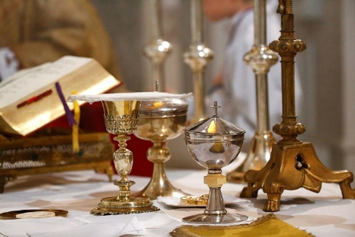
The Preface (Preface I for Easter)
Extending his hands, he says:
The Lord be with you.
The people reply:
And with your spirit.
The Priest, raising his hands, continues:
Lift up your hearts.
The people:
We lift them up to the Lord.
The Priest, with hands extended, adds:
Let us give thanks to the Lord our God.
The people:
It is right and just.
The Priest, with hands extended, continues the Preface.
It is truly right and just, our duty and our salvation,
at all times to acclaim you, O Lord,
but on this day
to laud you yet more gloriously
when Christ our Passover has been sacrificed.
For he is the true Lamb
who has taken away the sins of the world;
by dying, he has destroyed our death,
and by rising restored our life.
Therefore, overcome with paschal joy,
every land, every people exults in your praise
and even the heavenly Powers, with the angelic hosts,
sing together the unending hymn of your glory,
as they acclaim::
At the end of the Preface he joins his hands and concludes the Preface with the people,
singing or saying aloud:

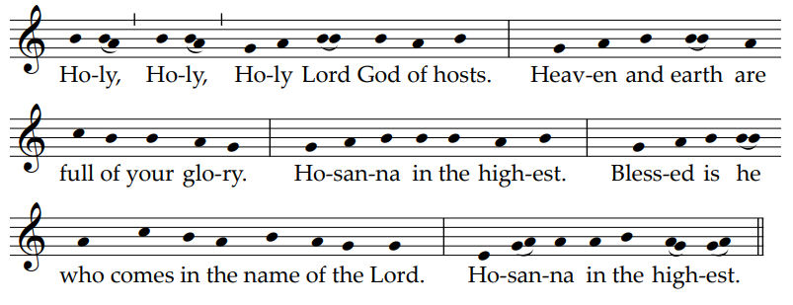
Eucharistic Prayer I (The Roman Canon)
(with text particular to the Octave of Easter)
The Priest, with hands extended, says:
To you, therefore, most merciful Father,
we make humble prayer and petition
through Jesus Christ, your Son, our Lord:
He joins his hands and says:
that you accept
He makes the Sign of the Cross once over the bread and chalice together, saying:
and bless X these gifts, these offerings, these holy and unblemished sacrifices,
With hands extended, he continues:
which we offer you firstly
for your holy catholic Church.
Be pleased to grant her peace,
to guard, unite and govern her
throughout the whole world,
together with your servant Francis our Pope
and Ronald our Bishop,
and all those who, holding to the truth,
hand on the catholic and apostolic faith.
Remember, Lord, your servants (N. and N.)
The Priest joins his hands and prays briefly for those for whom he intends to pray. then, with hands extended, he continues:
and all gathered here,
whose faith and devotion are known to you.
For them we offer you this sacrifice of praise
or they offer it for themselves
and all who are dear to them:
for the redemption of their souls,
in hope of health and well-being,
and paying their homage to you,
the eternal God, living and true.
Celebrating the most sacred day
of the Resurrection of our Lord Jesus Christ in the flesh,
and in communion with those whose memory we venerate,
especially the glorious ever-Virgin Mary,
mother of our God and Lord, Jesus Christ,
and blessed Joseph, her Spouse,
your blessed Apostles and Martyrs,
Peter and Paul, Andrew,
James, John,
Thomas, James, Philip,
Bartholomew, Matthew,
Simon and Jude;
Linus, Cletus, Clement, Sixtus,
Cornelius, Cyprian,
Lawrence, Chrysogonus,
John and Paul,
Cosmas and Damian
and all your saints; we ask that through their merits and prayers,
in all things we may be defended
by your protecting help.
Therefore, Lord, we pray:
graciously accept this oblation of our service,
that of your whole family,
which we make to you
also for those to whom you have been pleased to give
the new birth of water and the Holy Spirit,
granting them forgiveness of all their sins;
order our days in your peace,
and command that we be delivered from eternal damnation
and counted among the flock of those you have chosen.
Holding his hands extended over the offerings, he says:
Be pleased, O God, we pray,
to bless, acknowledge,
and approve this offering in every respect;
make it spiritual and acceptable,
so that it may become for us
the Body and Blood of your most beloved Son,
our Lord Jesus Christ.
He joins his hands.

In the formulas that follow, the words of the Lord should be pronounced clearly and distinctly, as the nature of these words requires.
On the day before he was to suffer,
He takes the bread and, holding it slightly raised above the altar, continues:
he took bread in his holy and venerable hands,
He raises his eyes.
and with eyes raised to heaven
to you, O God, his almighty Father,
giving you thanks, he said the blessing,
broke the bread
and gave it to his disciples, saying:
He bows slightly.
Take this, all of you, and eat of it,
for this is my Body,
which will be given up for you.
He shows the consecrated host to the people, places it again on the paten, and genuflects in adoration.
After this, the Priest continues:
in a similar way, when supper was ended,
He takes the chalice and, holding it slightly raised above the altar, continues:
he took this precious chalice
in his holy and venerable hands,
and once more giving you thanks, he said the blessing
and gave the chalice to his disciples, saying:
He bows slightly.
Take this, all of you, and drink from it,
for this is the chalice of my Blood,
the Blood of the new and eternal covenant,
which will be poured out for you and for many
for the forgiveness of sins.
Do this in memory of me.
He shows the chalice to the people, places it on the corporal, and genuflects in adoration.
Then he says:
The mystery of faith.
And the people continue, acclaiming:
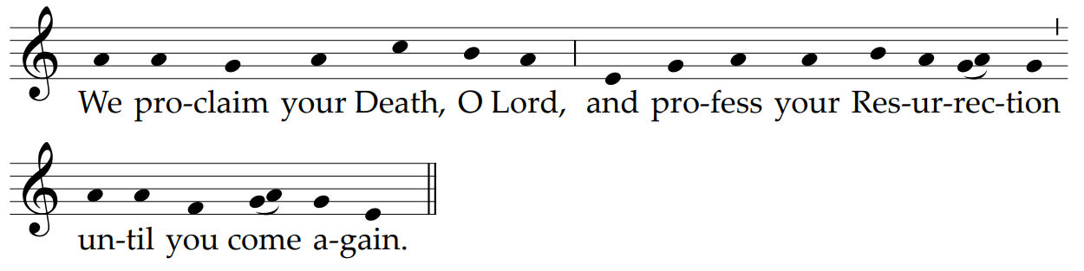
Then the Priest, with hands extended, says:
Therefore, O Lord,
as we celebrate the memorial of the blessed Passion,
the Resurrection from the dead,
and the glorious Ascension into heaven
of Christ, your Son, our Lord,
we, your servants and your holy people,
offer to your glorious majesty
from the gifts that you have given us,
this pure victim,
this holy victim,
this spotless victim,
the holy Bread of eternal life
and the Chalice of everlasting salvation.
Be pleased to look upon these offerings
with a serene and kindly countenance,
and to accept them,
as once you were pleased to accept
the gifts of your servant Abel the just,
the sacrifice of Abraham, our father in faith,
and the offering of your high priest Melchizedek,
a holy sacrifice, a spotless victim.
Bowing, with hands joined, he continues:
In humble prayer we ask you, almighty God:
command that these gifts be borne
by the hands of your holy Angel
to your altar on high
in the sight of your divine majesty,
so that all of us, who through this participation at the altar
receive the most holy Body and Blood of your Son,
He stands upright and signs himself with the Sign of the cross, saying:
may be filled with every grace and heavenly blessing.
With hands extended, the Priest says:
Remember also, Lord, your servants (N. and N.),
who have gone before us with the sign of faith
and rest in the sleep of peace.

He joins his hands and prays briefly for those who have died and for whom he intends to pray.
Then, with hands extended he continues:
Grant them, O Lord, we pray,
and all who sleep in Christ,
a place of refreshment, light and peace.
He strikes his breast with his right hand, saying:
To us, also, your servants, who, though sinners,
And, with hands extended he continues:
hope in your abundant mercies,
graciously grant some share
and fellowship with your holy Apostles and Martyrs:
with John the Baptist, Stephen,
Matthias, Barnabas,
Ignatius, Alexander,
Marcellinus, Peter,
Felicity, Perpetua,
Agatha, Lucy,
Agnes, Cecilia, Anastasia
and all your Saints;
admit us, we beseech you,
into their company,
not weighing our merits,
but granting us your pardon,
he joins his hands.
through Christ our Lord.
And he continues:
Through whom
you continue to make all these good things, O Lord;
you sanctify them, fill them with life,
bless them, and bestow them upon us.
He takes the chalice and the paten with the host and, elevating both, he says:
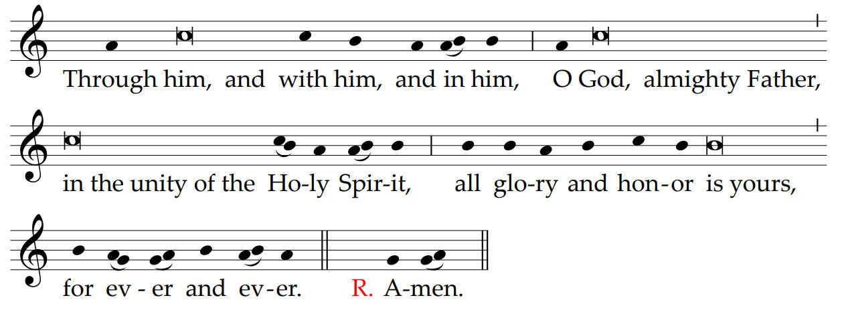

The Communion Rites
After the chalice and paten have been set down, the Priest, with hands joined, says:
At the Savior’s command
and formed by divine teaching,
we dare to say:
He extends his hands and, together with the people, continues:
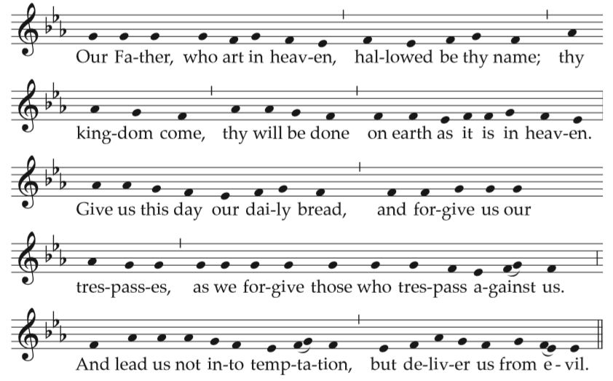
With hands extended, the Priest alone continues, saying:
Deliver us, Lord, we pray, from every evil,
graciously grant peace in our days,
that, by the help of your mercy,
we may be always free from sin
and safe from all distress,
as we await the blessed hope
and the coming of our Savior, Jesus Christ.
He joins his hands.
The people conclude the prayer, acclaiming:
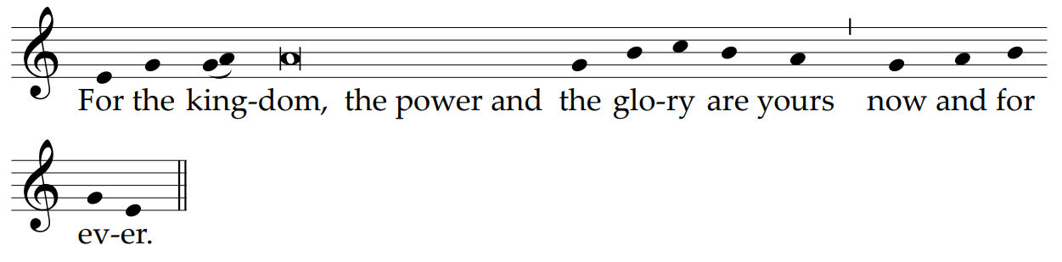

Then the Priest, with hands extended, says aloud:
Lord Jesus Christ,
who said to your Apostles:
Peace I leave you, my peace I give you;
look not on our sins,
but on the faith of your Church,
and graciously grant her peace and unity
in accordance with your will.
He joins his hands.
Who live and reign for ever and ever.
The people reply:
Amen.
The Priest, extending and then joining his hands, adds:
The peace of the Lord be with you always.
The people reply:
And with your spirit.

Then he takes the Host, breaks it over the paten, and places a small piece in the chalice, saying quietly:
May this mingling of the Body and Blood
of our Lord Jesus Christ
bring eternal life to us who receive it.
Meanwhile the following is sung or said:
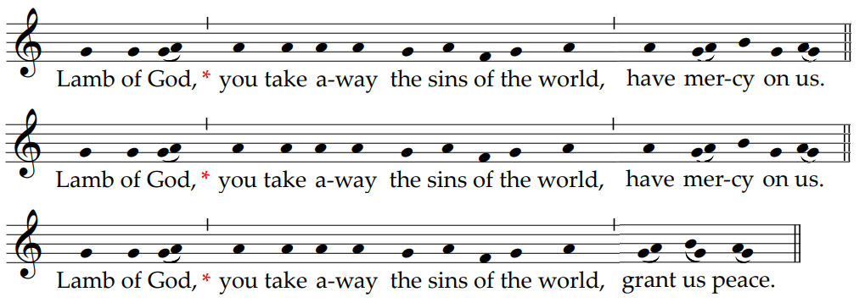
Then the Priest, with hands joined, says quietly:
Lord Jesus Christ, Son of the living God,
who, by the will of the Father
and the work of the Holy Spirit,
through your Death gave life to the world,
free me by this, your most holy Body and Blood,
from all my sins and from every evil;
keep me always faithful to your commandments,
and never let me be parted from you.
The Priest genuflects, takes the host and, holding it slightly raised above the paten or above the chalice, while facing the people, says aloud:
Behold the Lamb of God,
behold him who takes away the sins of the world.
Blessed are those called to the supper of the Lamb.
And together with the people he adds:
Lord, I am not worthy
that you should enter under my roof,
but only say the word
and my soul shall be healed.

The Priest, facing the altar, says quietly:
May the Body of Christ
keep me safe for eternal life.
And he reverently consumes the Body of Christ.
Then he takes the chalice and says quietly:
May the Blood of Christ
keep me safe for eternal life.
And he reverently consumes the Blood of Christ.
While the Priest is receiving the Body of Christ, the Communion Chant begins.
Communion Antiphon Cf. Jn 20:27
Bring your hand and feel the place of the nails,
and do not be unbelieving but believing, alleluia.
The Priest purifies the paten over the chalice and also the chalice itself.
While he carries out the purification, the Priest says quietly:
What has passed our lips as food, O Lord,
may we possess in purity of heart,
that what has been given to us in time
may be our healing for eternity.
Then the Priest may return to the chair. If appropriate, a sacred silence may be observed for a while, or a psalm or other canticle of praise or a hymn may be sung.

The Prayer After Communion
Then, standing at the altar or at the chair and facing the people, with hands joined, the Priest says:
Let us pray.
Then the Priest, with hands extended, says the Prayer after Communion:
Grant, we pray, almighty God,
that our reception of this paschal Sacrament
may have a continuing effect
in our minds and hearts.
Through Christ our Lord.
The people acclaim:
Amen.

The Concluding Rites
If they are necessary, any brief announcements to the people follow here.
In the Diocese of Harrisburg: The Prayer for the Intercession of Saint Michael:
Saint Michael the Archangel,
defend us in battle.
Be our defense against the wickedness and snares of the Devil.
May God rebuke him, we humbly pray,
and do thou,
O Prince of the heavenly hosts,
by the power of God,
thrust into hell Satan,
and all the evil spirits,
who prowl about the world
seeking the ruin of souls. Amen.
During this period of the closing of the churches: An Act of Spiritual Communion
My Jesus,
I believe that You
are present in the Most Holy Sacrament.
I love You above all things,
and I desire to receive You into my soul.
Since I cannot at this moment
receive You sacramentally,
come at least spiritually into my heart.
I embrace You as if You were already there and unite myself wholly to You.
Never permit me to be separated from You. Amen.

Then the dismissal takes place. The Priest, facing the people and extending his hands, says:
The Lord be with you.
The people reply:
And with your spirit.
The Priest says the invitation:
Bow down for the blessing.
Then the Priest, with hands outstretched over the people, says:
May God, who by the Resurrection of his Only Begotten Son
was pleased to confer on you
the gift of redemption and of adoption,
give you gladness by his blessing.
R. Amen.
May he, by whose redeeming work
you have received the gift of everlasting freedom,
make you heirs to an eternal inheritance.
R. Amen.
And may you, who have already risen with Christ
in Baptism through faith,
by living in a right manner on this earth,
be united with him in the homeland of heaven.
R. Amen.
And may the blessing of almighty God,
the Father, and the Son, X and the Holy Spirit,
come down on you and remain with you for ever.
R. Amen.
To dismiss the people, the priest sings or says:
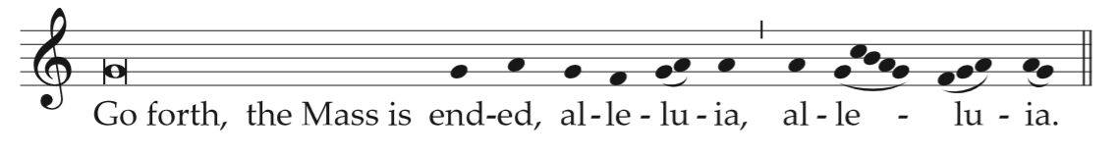
All reply:
