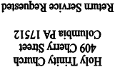

NON PROFIT ORG

US POSTAGE PAID

PERMIT NO 46

LANCASTER PA 17601

FALL 2015
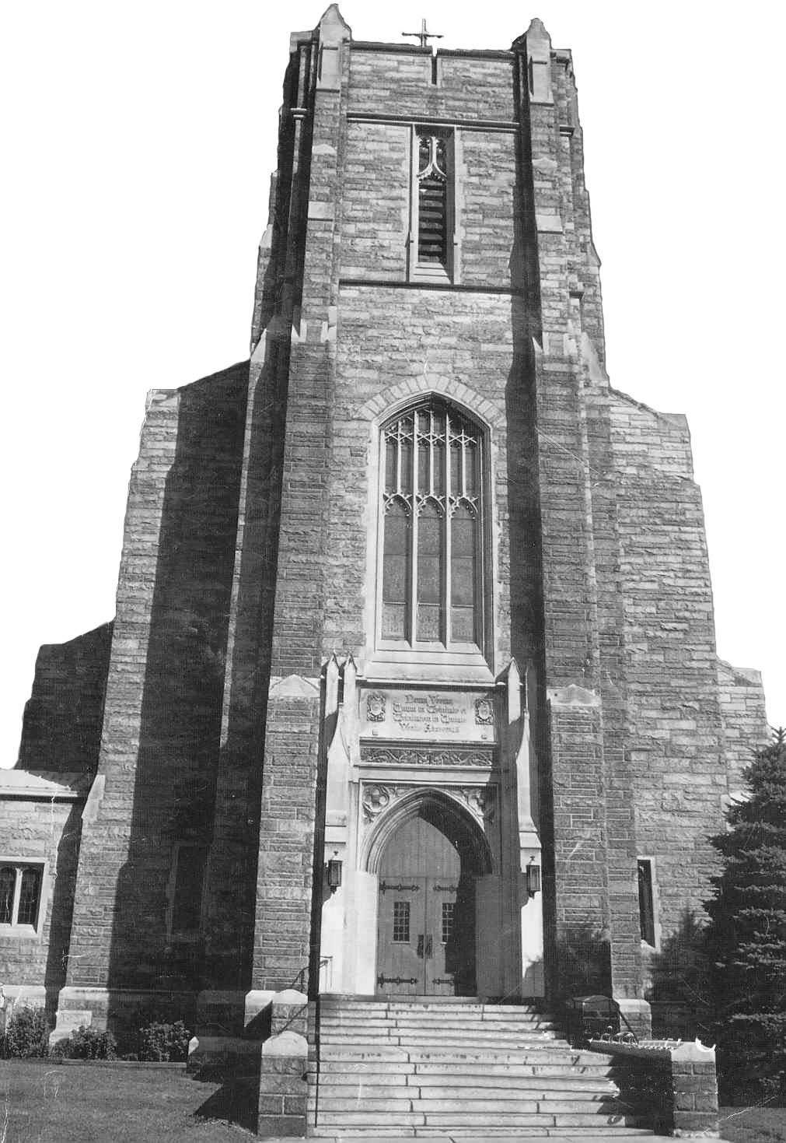
Holy Trinity

Herald
Tribune

KNOW YOUR FAITH

Some years ago a song that was quite popular was called Born Free. Some of the lyrics are as follows: “Born free, as free as the wind blows. Born free to follow your heart. Stay free where no walls divide you.”
Looking into the Scriptures we find that God has made every human being into His divine likeness. God said, “Let us make man in our own image.” (Genesis 1:26) Since God is free, and human beings are created with likeness, it means that every human being who enters this world is blessed with the gift of freedom, as the title of the song expresses it, one is born free.
However, a person is not born free “to follow one’s heart.” That is because every person is free, and to respect the freedom of all people, one’s personal freedom is restricted. Consequently, freedom is not license to do as one pleases. In the Scriptures, God tells us that freedom is not freedom from, but freedom for. Respecting God’s rights, and the rights of every person, true freedom is for service — service of God and service of neighbor. In the Bible the Hebrew word for freedom is “ebed,” and in Greek “doulos.” These words mean servant, slave. Consequently, freedom means loving service of God and of one another. “If, when you were called you were a slave, do not let this bother you, but if you should have the chance of being free, accept it. A slave, when he is called in the Lord, becomes the Lord’s freed man, and a freed man called in the Lord becomes Christ’s slave.” (I Corinthians 7:21-22)
A free person is an obedient person. The word “obedience” is derived from the Latin verb “audire” and the prefix “ob.” It means to listen to, to be open to. Thus a free person is one who is obedient to God’s laws. “You are slaves of no one except God, so behave like a free man, and never use your freedom as an excuse for wickedness.” (I Peter 2:16)
Eureka

An ancient Greek mathematician was Archimedes. After a long and diligent research, he discovered the principle of physics which states that the apparent loss of weight is equal to the weight of the fluid displaced when a body is immersed in a fluid. When he made that discovery, he ran through the city of Syracuse, shouting “Eureka.” Eureka is a Greek word which means, “I have found” or better “I have a made a discovery.”
In the Gospel of St John, we read about a similar incident. Andrew made a discovery. He found the One his ancestors, and indeed, all the ancient Hebrew people were longing for for centuries. He had found the Messiah in the person of Jesus. As Archimedes ran through the city of Syracuse, shouting, “Eureka,” Andrew ran to his home and shouted to his brother Simon (Peter): “I have made a discovery.” He first found his own brother Simon and told him, “We have found the Messiah.” (John 1:41) Andrew was not content to dedicate his life to Christ, he wanted others to share in his good fortune, and so he brought his brother to our Lord.
Somewhere in our past history, someone or very likely, some persons, acted like Andrew in our behalf. They brought us the good news that Jesus is the Messiah, and through their words and actions and encouragement, they led us to Christ. And now we have the privilege of being called Christ’s followers, that is Christians.
Writing in the Joy of the Gospel, Pope Francis said, “Let us go forth, then, let us go forth to offer everyone the life of Jesus Christ” (para. 49). As people in our own past history have led us to Christ by their words and example, we have chosen to follow in their footsteps. We have been acting as Andrew to many people. Our Christ-like way of living has been greatly influential in assisting others to deepen their relationship with Christ, the Savior, and to be enriched with His Divine life.
For the wonderful gift of faith in Christ, we thank the Holy Spirit, we thank Him also, for assisting us in aiding others in the path of holiness. And we pray to Him that, with His help, we will grow in our faith, and assist others in doing the same.

WOW, YOU DID IT AGAIN!

A very sincere thank you to all who helped in any way with the Chicken Barbecue --- from working the day of the sale to buying those delicious chicken dinners. Because of your support, the sale was a huge success. ...again, thank you!

FALL HOUSECLEANING

As you do your fall housecleaning, remember that the Archive Committee is always looking for memorabilia. Don’t discard those pictures and newspaper clippings that are hiding in the corners of drawers and the shelves of closets. If you find any of these items, please bring them to the rectory with a brief description of the parish event and names and dates, if possible.

CATHOLIC READING CENTER

As fall changes into winter, remember to visit the reading center, located in the vestibule of our church. It provides a source of continuing educational and inspirational material as well as current information about the Church and about our faith.
Your patronage of this reading center will assist the Saint Vincent de Paul Society in responding to its ministry to the needy.

WHO ARE THE FRANSALIAN MISSIONARIES?

They are Missionaries of Saint Francis De Sales (MSFS), better known as Fransalian Missionaries. The religious order was founded in France in 1838 by Father Peter Mermier
They work in the USA, India, France, Switzerland, England, Brazil, Chad, Namibia, Tanzania, Mozambique, Australia, Austria, Germany, Philippians, West Indies, Chile, Trinidad and other countries.
When called upon they serve at the request of Bishops from various dioceses all over the world. Today 49 priests are in pastoral ministries in thirteen states with international headquarters in Rome. The USA region headquarters is located in Whitehouse, Texas. For more information check their website: www.fransaliansusa.com/.

INQUIRING MINDS, SEARCHING HEARTS WELCOME
Do you want to learn more about the Catholic faith? Have you ever wanted to discuss your religious beliefs with your family and friends, but lacked the words to express your thoughts? Do you want to ask questions about the church; but, are too timid or shy?
If you answered “yes” to one or all of these questions, then RCIA (The Rite of Christian Initiation of Adults) is for you! RCIA is a spiritual journey for those who want to learn more about their Catholic faith as well as for those who are searching for “the right faith” for them.
The class (RCIA) meets every Monday (6:30-7:30 p.m.). The atmosphere is casual and very friendly. Everyone is welcome … especially you!

After much deliberation and consultation between Holy Trinity and Saint Peter parishes and with the blessing from the Bishop, Father Lawrence coordinated the consolidation of the two schools in what is know today as Our Lady of the Angels.
Some major improvements were made at the cemetery. The entire roadway was replaced, sections were widened and repaved. A new crucifix was installed at the cemetery depicting the three persons of the Blessed Trinity. The crucifix, donated anonymously by a Holy Trinity family, was sculptured in Italy and blessed on Trinity Sunday, 2008, by Father.
While serving as our pastor, Father Lawrence had additional duties as one of a handful of priest consulters who advised the Bishop. He was also a member of the Diocesan Finance Council and served 20 years as Dean of the Northern Deanery of Lancaster County.
In retirement Father Lawrence was given the title of Pastor Emeritus and will have residence in the rectory at Holy Trinity. The people of the parish say thank you for your leadership and spiritual guidance during your tenure as our shepherd. . . . . . . . YOU ARE A PRIEST FOEVER IN THE LINE OF MELCHIZEDEK. May God continue to shower you with His graces.

There is a new resident at Holy Trinity Convent

Meet Sister Daniel Marie McCarthy, OSF., a native of County Cork, Ireland, who arrived early in September and is residing with Sister Anna in the Cherry Street Convent.
She joined the Sisters of Saint Francis, Philadelphia, in 1962. Her Glenn Riddle formation class included a Holy Trinity “daughter” Sister Jean Wickenheiser, OSF. The two young postulants were professed in 1965 and celebrated their 50th Golden Jubilee this past summer. We offer our congratulations!
Sister Daniel earned her Bachelor of Arts degree at Our Lady of the Angels College, now Neumann University. She taught primary grades, first and second graders, for 49 years having just retired this past June. The majority of her teaching career was in parochial schools in New Jersey, though she had one three year assignment in Massachusetts.
For the past several years she taught at Saint Rose School in Freehold, New Jersey, which coincidently is the home parish of Bruce Springsteen. Bruce was educated by the good Sisters of Saint Francis at Saint Rose.
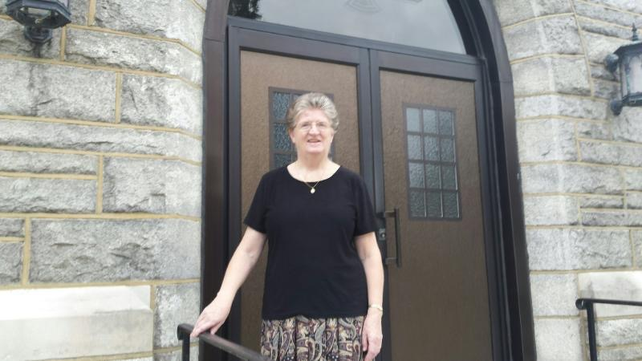
Sister is the 212th member of her Order to be assigned or reside with us since the first group of nuns arrived in September, 1869. That’s 146 years ago. We are honored and blessed to have the Franciscans with us all these years.
Welcome Sister Daniel, and we hope your stay will be long, rewarding and enjoyable. There is an old Irish saying. . . . May neighbors respect you, trouble neglect you, the angels protect you, and heaven accept you. We welcome you with open arms.

In her book Listening to Others, Joyce Huggett writes about the importance of learning to listen and to respond effectively to those in difficult situations. As she relates some of her own experiences of listening to suffering people, she mentions that they often thank her for all that she’s done for them. “On many occasions,” she writes, “I have not ‘done’ anything. I have ‘just listened.‘“ I quickly came to the conclusion that ‘just listening’ was indeed an effective way of helping others.

Vacation Bible School

Vacation Bible School was held for one week in July at Our Lady of the Angels School. Hosted by Holy Trinity Parish and open to the community, it was once again a popular mid-summer event for children ages five through twelve. This year’s VBS theme was “Parade Around the Our Father.” The Youth Group, led by Rich Groff, opened each evening with a circus of animals and clowns that paraded into the parish center to greet the children and perform a skit. During the course of the week, the children followed an itinerary that included a religious lesson, a craft, music, playing a game of skill, and snack. They read about St. Joseph of Cupertino (“The Flying Friar”) who was able to levitate. On the last evening, the children and their invited family and friends attended Eucharistic Adoration led by Father Lawrence and Father Speitel. VBS is coordinated by Rich Groff and Sister Anna each year and supported by countless volunteers.

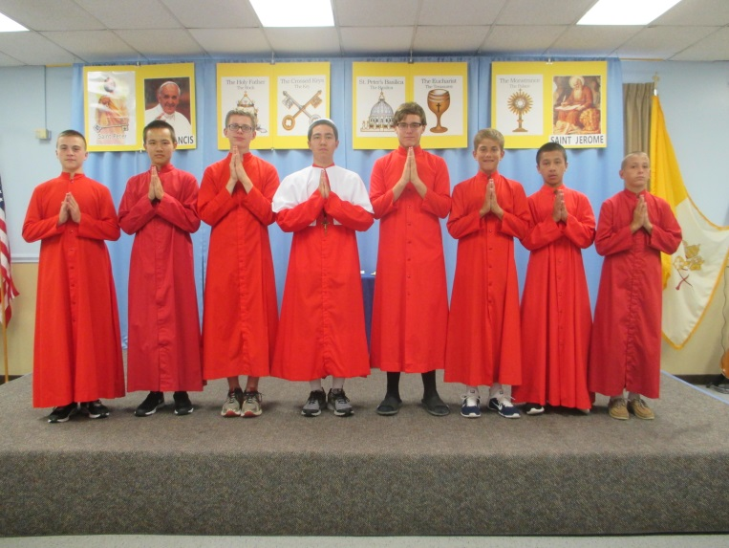

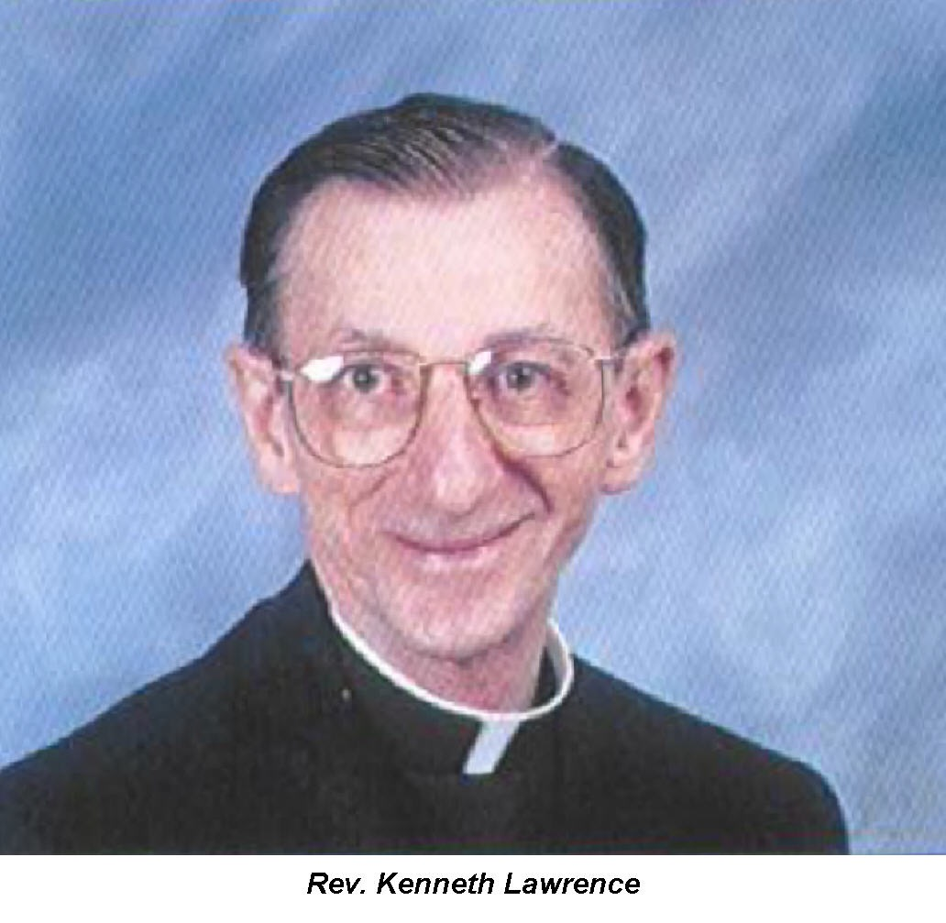
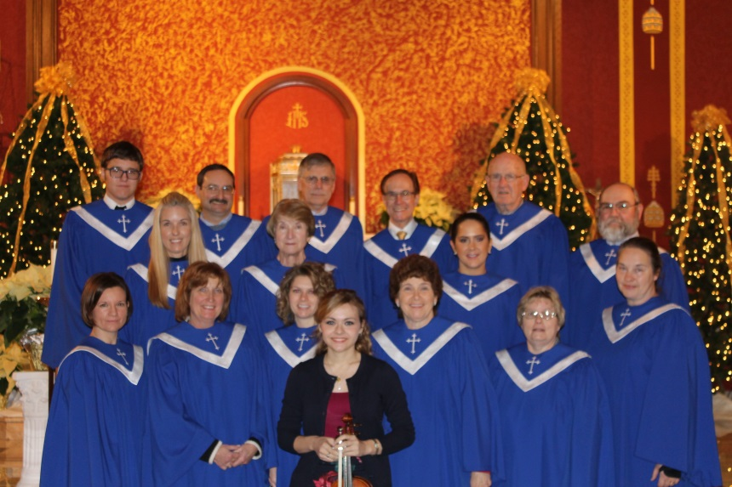

Choir Reconvenes

The parish choir reconvened on September 17 for a year-long schedule of rehearsals and service in music ministry. The members are eager to share their passion for sung liturgy with the parish community. In addition to the 19 choir members returning, a warm welcome was extended to Staci Henry who earned her undergraduate degree at Penn State and plans to pursue a Master’s Degree program. Staci rejoins the chamber orchestra sharing her talents in the string section.
With the objective to bring a broad experience of the Church’s musical tradition, i.e. chant and polyphony to liturgical celebrations, the choir will offer the following choral pieces, appropriate to and reflecting the readings of the liturgies being celebrated:

Oct. 4 Not for Tongues of Heaven’s Angels . . . . . . . . . . . . . . . . . . .Michael Joncas
Oct. 25 Locus Iste (This place is the work of God.) . . . . . . . . . . . . . . . . . .Philip W.J. Stopford
Nov. 1 O Blessed Are the Poor in Spirit . . . . . . . . . . . . . . . . . . . . . .Chant, Adapt. By Richard Proulx
Dec. 6 On Jordan’s Bank . . . . . . . . . . . . . . . . . . . . . . . . . . . . . . . . .William Ferris
Dec. 25 Hodie Christus Natus Est . . . . . . . . . . . . . . . . . . . . . . . . . . . M. Bedford
Sleep, Holy Babe . . . . . . . . . . . . . . . . . . . . . . . . . . . . . . . . .T. Keesecker
Tollite Hostias (Praise Ye the Lord) . . . . . . . . . . . . . . . . . . C. Sant-Saens
From Christmas Oratorio
Jan. 3 Tollite Hostias
Feb. 7 Softly and Tenderly . . . . . . . . . . . . . . . . . . . . . . . . . . . . . . . Will L. Thompson
Mar. 6 Come Home, Softly and Tenderly .. . . . . . . . . . . . . . . . . . . . .Paul Tate

RETIREMENT OF FATHER KENNETH LAWRENCE

After 21 years and five months as our pastor, Father Lawrence announced that he would be retiring, on the Feast of the Assumption, August 15th, due to his declining health.
Many of the parishioners were filled with tears as the announcement was made. The Hanover native has had a blessed and rewarding vocation serving the people of the Harrisburg Diocese for 55 years. Following his ordination by Bishop George L. Leech, on May 14, 1960, his first assignment was as assistant pastor at St. Joseph Church, Lancaster.
He later served as assistant pastor at St. Mary’s Church in York; Saint Theresa’s, in New Cumberland, and then back to York for assignment at Saint Joseph’s Parish.
In 1973 he was named pastor at Saint Andrew’s Church in Waynesboro, Franklin County. There he served as pastor for ten years. His next pastoral assignment was Saint Francis Xavier Church in Gettysburg, where he served for 11 years.
After the death of our seventh pastor, Father Stephen Rolko, Bishop Nicholas C. Dattilo assigned Father Lawrence to Holy Trinity. The appointment as our eighth pastor was made March 9, 1994.
During more than two decades Father Lawrence has been very busy overseeing improvements to our church, cemetery and school property that have included upgrading the pipe organ, repainting interior walls and restoring the exterior of the church and the bell tower. He was instrumental in the installation of a new heating and air-conditioning system in 1999. A handicap ramp at the church was replaced to meet federal regulations. The magnificent Steinway piano was purchased and installed in the choir loft to enhance liturgical services.
Additionally, antiquated wiring and lighting have been replaced in the sanctuary and seating area of the church. The wooden altar was replaced and a marble one installed that came from a former church in the coal regions.
Under Father’s guidance parish organizations, families and some individuals covered costs to repair stained glass windows in the church. During the summer of 2005, he proposed painting the mural of Jesus on the outer wall of the school building. He said it would draw people’s attention to Christ and what He is all about.
The parish celebrated its 150th Anniversary during Father’s reign with a year long observance beginning on September 13, 2009, and culminating on May 30, 2010.
The school was always dear to Father’s heart. Many improvements were instituted under his guidance that included: dedicating a new science room, installing new lighting in the gym, carpeting and installing new lighting in the school library, as well as carpeting all the classrooms. A classroom was converted into offices for the principal and secretary. The security and fire alarm systems were updated. A major improvement included air-conditioning all class rooms; consequently, creating a better environment for students and faculty.

Meet our new pastor

Father Michael P. Reid was named ninth pastor of Holy Trinity Parish by Bishop Ronald Gainer. He succeeds Father Kenneth Lawrence who retired on the Feast of the Assumption.
Father Reid will continue serving as pastor of Saint Peter Parish, a post he assumed in June of this year. He has a varied and extensive background. Upon graduating from Bishop McDevitt High School in Harrisburg, he attended the University of Notre Dame. He was a member of Navy ROTC and graduated with a Bachelor’s Degree in Sociology with the Class of 1978.
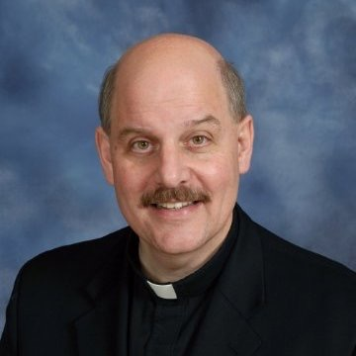
Upon graduation he served in the U.S. Navy, as a Surface Line Officer, for the next ten years and eight months. Leaving the Navy, Father Reid enrolled at Weidner University Law School, where he earned his Juris Doctor, Law, cum laude in 1992.
He practiced law for nearly three years in Harrisburg. And in 1994 he served as a judicial clerk for the Honorable Thomas Saylor, Judge of the Superior Court of Pennsylvania.
In 1995 Father Michael answered the calling from God and entered Pope Saint John XXIII National Seminary in Massachusetts earning his Master of Divinity Degree. He was ordained in 2000.
Father Michael served as Parochial Vicar at Saint John the Baptist Parish, New Freedom, York County, and at Saint Francis Xavier Parish, Gettysburg, Adams County. Then he was assigned as Secretary to the Tribunal for the Diocese in Harrisburg.
His first assignment as pastor led him to the Assumption of the Blessed Virgin Mary Parish in Lebanon. A post he held for nine years. The next assignment, June 2014, took him to Mechanicsburg, Cumberland County, to become pastor of Saint Katharine Drexel Parish where he served until June 2015, when he was named pastor of Saint Peter Parish here in Columbia. Father Michael will continue as the shepherd of both Saint Peter and Holy Trinity Parishes with a residence at Saint Peter Rectory.
And it should come as no surprise that Father Michael serves as Chaplain for the Notre Dame Clubs of Gettysburg and Harrisburg. Go Irish . . . . and welcome Father.

Choir Combines for Anniversary Mass

The adult choirs of Holy Trinity and St. Peter’s, along with St. Peter’s Youth Choir, have combined to form an Anniversary Choir to sing at the Mass on October 25 celebrating 150 years of Catholic Education in Columbia. During the Offertory the choir will offer Locus Iste, a choral piece in the tradition of English cathedral music. Enhancing this sung liturgy will be the instrumentalists of the chamber orchestra.

Music Ministry Invitation

A special invitation to join the choir and cantor is extended to high school/college students and adults who love to sing. Just as liturgy is formative through fixed texts and rituals, so music – through song or instrument – serves as formation and as pastoral care for the People of God.
~Welcome, you belong!~

Parish Picnic 2015

The Men’s Club held its annual Parish Picnic, September 13, in the parish center. It was a beautiful Sunday afternoon. Men’s Club President, Hal Snyder, welcomed everyone and reminded the crowd that the picnic is made possible by the funds raised at the parish festival held in June. He thanked anyone present who had contributed in any way to the success of the festival.
This year two anniversaries are being recognized, Catholic Education began at Holy Trinity 150 years ago, September 1, 1865 and the school building marks its 100th anniversary. It was dedicated on October 24, 1915. Hal talked about the highlights of its construction as well as the many renovations and remodels it has undergone over the.
Hal welcomed Father Reid, Father Augustine, Father Fischer, Sister Anna, Sister Helene and Sister Daniels to this year’s picnic. He announced that October 25th there will be a commemorative Mass, celebrated by Bishop Ronald Gainer, followed by an open house and reception to mark these two special anniversaires.
Ed Wickenheiser welcomed Father Lawrence to the picnic and announced that a committee has been formed to purchase a statue for the school garden in honor of Father Lawrence. He said there will be opportunities in the near future for parishioners and friends to donate money toward purchasing the statue.
The Kelly Trio of Harrisburg provided entertainment for the afternoon. The center aisle of the hall quickly became the unofficial dance floor as the band played some old standards as well as contemporary music.
There were over 50 free door prizes for adults and children awarded by numbered tickets. Some of the prizes included a Galileo thermometer, clock and picture frame combo gift sets, a wooden likeness of the modern day Holy Trinity school building, goldfish crackers, and 300 club tickets. As has become a tradition, several rounds of BINGO were played to close out the day. Prizes for BINGO included ice cream and candy.
As a reminder, the parish Christmas Party will be held on the first Saturday in December, as it has for many years. This year it will be December 5, 2015. The picnic and Christmas party are free and again made possible by funds raised during the parish festival.

Pastoral Council
The Mission for Evangelization Part IV

In this newsletter we will continue the series in review of the Parish Pastoral Council’s areas of Mission. Our first area of Mission is Evangelization.

Evangelization is expressed as a continual process by which the church strives to deepen the faith of those who believe and bring the Good News to those who do not believe.

In the Mission for Evangelization we must constantly seek innovative ways to reach out to others with the message of God’s love plus be filled with creativity of the Spirit. Also, we must work closely with the other Parish Pastoral Council Area of Missions and parish organizations. This should provide the stimulus by which the entire faith community becomes a bearer of Good News.

The Parish Pastoral Council’s primary goals in Evangelization are:

- Spiritual renewals for those who profess faith in the Gospel of Jesus Christ, and drawn to clearly reflect that belief in their actions, relationships and whole lives.
- Outreach, for individuals, parishes and organizations to seek ways for sharing the faith with others including Catholics who do not currently practice their faith or those who do not practice any religion.

This area of Mission is constantly seeking new ways to reach out to others with the Message of God’s Love. Examples of this ministry carried out in our parish are:

- Eucharistic Adoration
- Home Visitations
- Outreach to Inactive Catholics
- Parish Missions
- Parish Retreats
- Rite of Christian Initiation of Adults

Our new Parochial Vicar

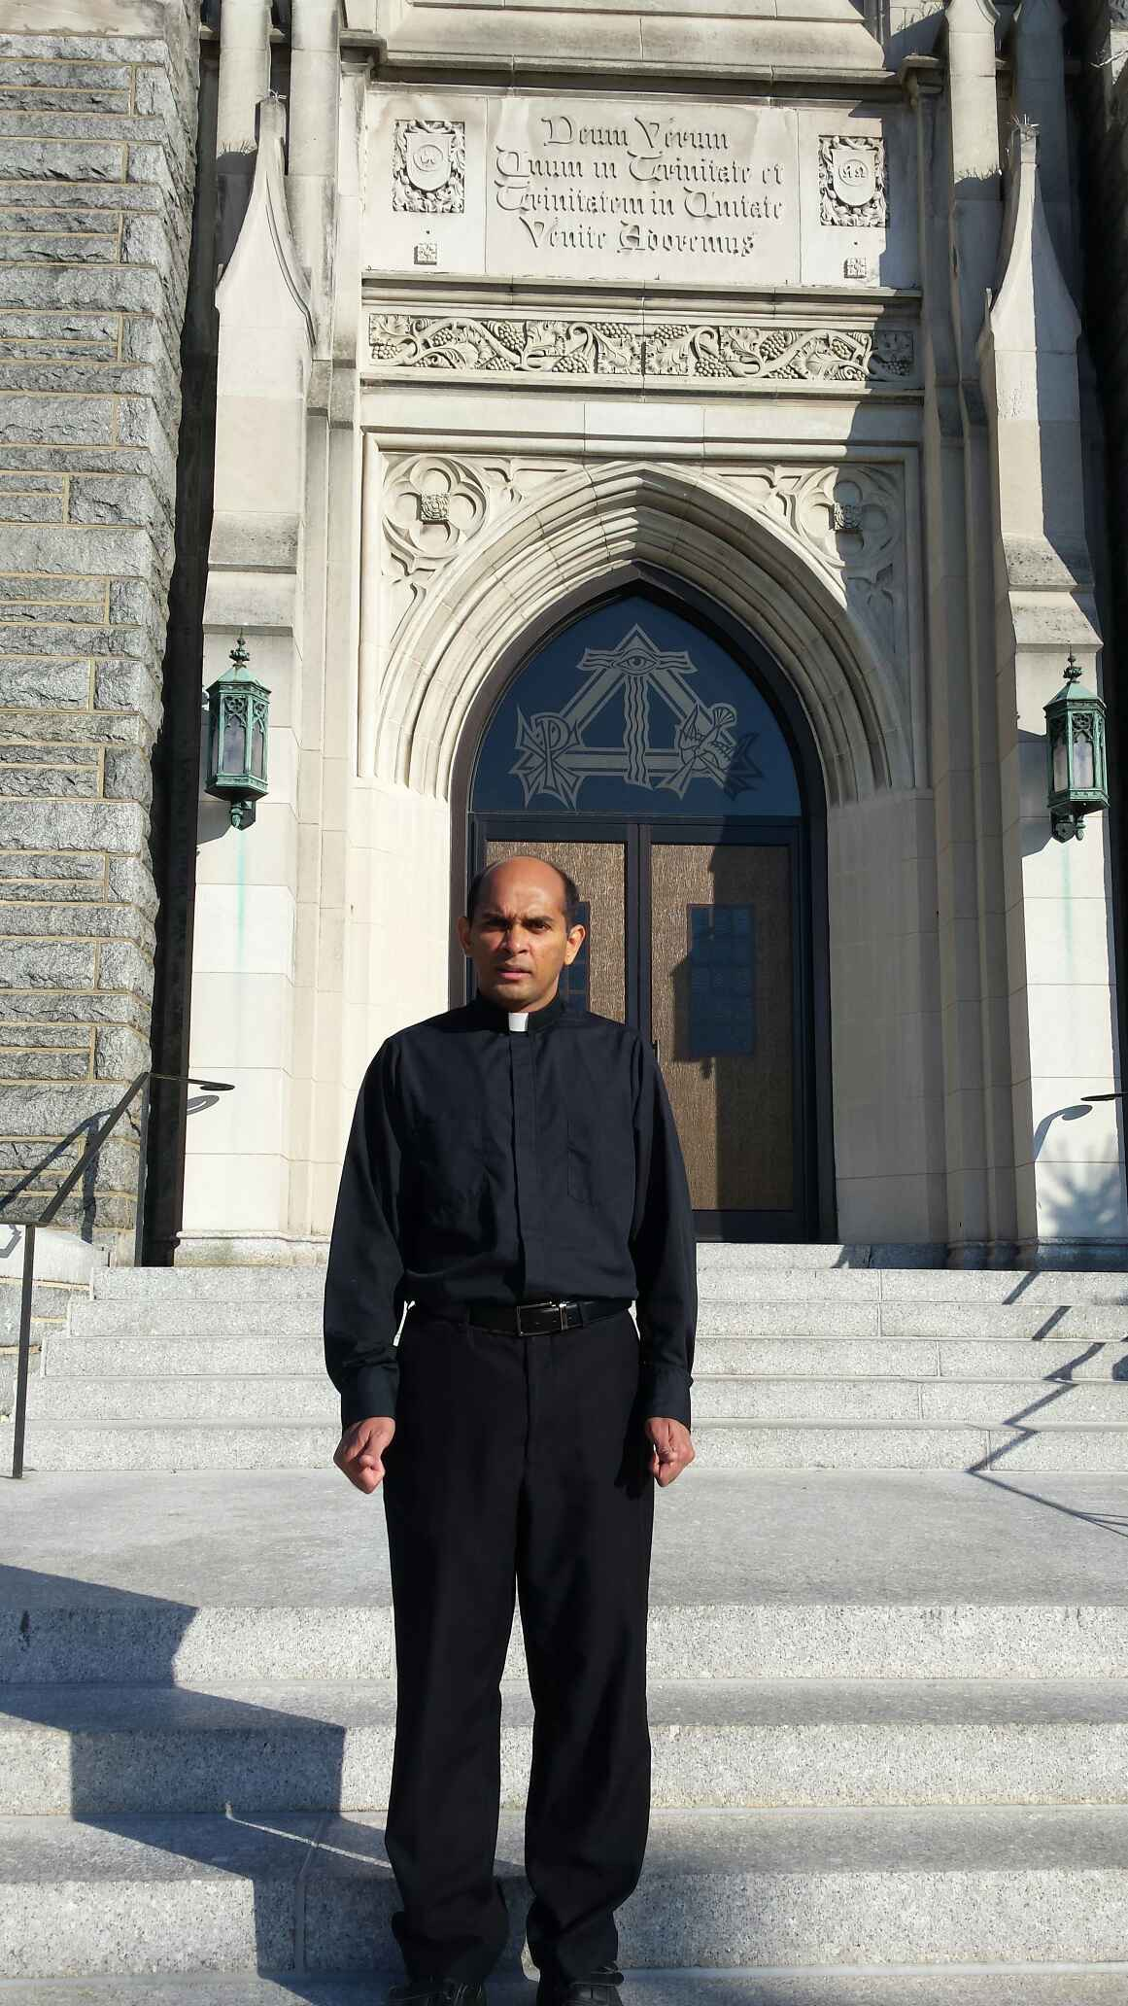
Father Augustine Joseph, MSFS, is a member of the Missionaries of St. Francis DeSales, also known as Fransalian Missionaries. Father Augustine joins two other members of his order now serving in the Diocese of Harrisburg.
He’ll be dividing his time between both parishes and will serve as a part-time Chaplain at Lancaster General Hospital with residence at Holy Trinity Rectory.
Father Augustine is from Ramapuram, Kerala State, India, where he graduated from Saint Augustine High School in 1991. The school is located in his home parish of the same name which serves 1500 families. Upon graduation he entered Saint Francis DeSales Seminary in Ettaumanor, Kerala State, where he studied for three years before entering the Novitiate for one year. He earned his Bachelor of Arts and of Philosophy from Suvidya College in Bangalore in 1998. It was one year of Regency in Bangalore and then off to study theology at Saint Joseph Pontifical Seminary in Aluva, India.
He was ordained on January 17, 2004, and his first assignment, by his order, was to teach English and history at Saint Francis High School & Boys’ Home in Chintamani. Then he spent three years in Vinayakumal Ashram in Kerala, South West India Province, the Diocese of Calicut. There he managed a small farm and assisted at Saint George Parish and School.
In December, 2008, Father Augustine was assigned as Chaplain at the Alexian Brothers Village, a retirement home, located near Chattanooga, Tennessee. Father served there until he received a call to become an assistant at Holy Trinity and Saint Peter Parishes
Father was born into the Syro-Malabar Rite, which is part of the Eastern Rite of the Catholic Church prominent in India. During his teen years he became a member of the Latin Rite of the church. Today his parents, Joseph and Philomina, a sister and four brothers still reside in India. He is the youngest of the siblings.

Forty Hours – September 27-29

The Rev. Paul Chaim Benedicta Schenck, BA, MA, EdD, LHD was the homilist for the Forty Hour Devotions at the end of September. He is the Director of the Respect Life Office and Ongoing Formation of Deacons and Continuing Education for Priests in the Diocese of Harrisburg. He spoke each evening, at the 7:00p.m. services.
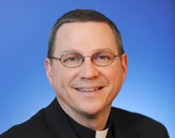
Father Schenck was raised Jewish, baptized a Christian at 16 years old, and trained in a missionary bible college. He attended an Evangelical Christian college, a Catholic University and seminary. A former Anglican minister, he is founder and chairman of the National Pro-Life Center in Washington, D.C., located directly across the street from the U.S. Supreme Court.
He is married and the father of eight living children, one child with God, two daughters-in-law and one son-in-law. The Schenck family came to the Catholic Church in 2004.
During the hospitalization of Father Lawrence, Father Schenck celebrated Mass several times on weekends as well as during the week. He is a featured columnist in the Diocesan newspaper The Catholic Witness and appears on EWTN.

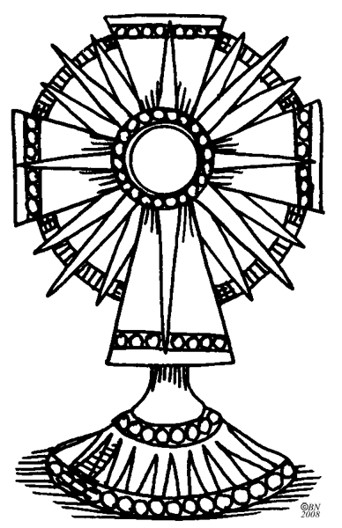

The challenge for the Parish Pastoral Council, in collaboration with the pastor is to lead the parish into active evangelization. The Bishops of the United States have published a document named Go and Make Disciples. The plan contains three goals:

Goal I = Believe – To bring about in all Catholics such an enthusiasm for their faith that, in
living their faith in Jesus, they freely share it with others.

Goal II = Share – To invite all people in the United States, whatever their social or cultural
background, to hear the message of salvation in Jesus Christ so they may come to join us in
the fullness of the Catholic faith.

Goal III = Transform – To foster gospel values in our society, promoting the dignity of the
human person, the importance of the family, and the common good of our society,
so that our nation may continue to be transformed by the saving power of Jesus Christ.

Pope Francis calls all of us to a new evangelization. He states Conversion is the one word that describes this new evangelization.

(In future newsletters other areas of Missions will be discussed.)

.

A little touch of heaven

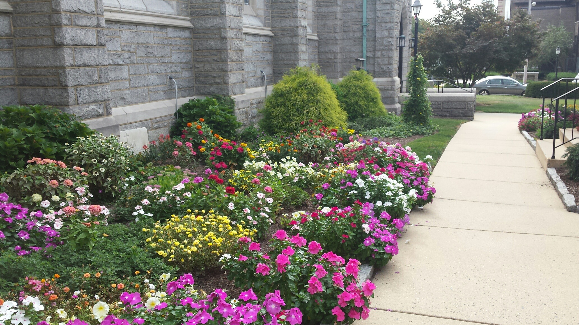
Have you taken the time to notice the beautiful flower gardens surrounding the rectory, church, and entrance to the parish center and school? It reminds one of an artist pallet filled with every imaginable pigment of oil paint. Or a preview of what awaits us in heaven.
What we have is a magnificent array of color and contrast in the form of flowers. The flower beds have been radiant from the beginning of spring, through the heat of summer and continue to offer beauty into the fall. It just didn’t happen over night.
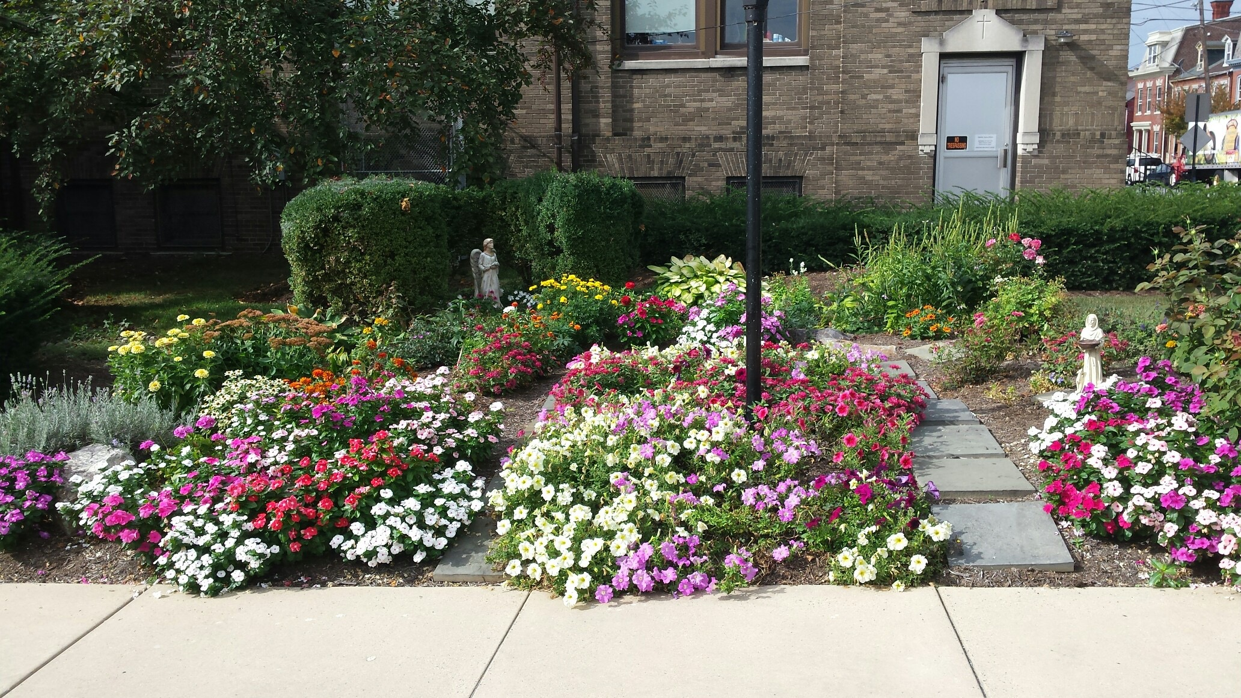
Sister Anna Cosgrove and her gardeners, Kathy Lutz and Charles “Skip” Newcomer are the individuals we owe a deep gratitude for this beauty. Their dedication combined with the work of the Lord in producing this magical carpet of flowers. We could say it is Sister’s answer to Longwood Gardens. The “Holy Gardeners” labor under the hot sun, pruning, deadheading and weeding several times a week. They call it a labor of love and a tribute to the Blessed Mother.
John Harrigan once said, “Happiness held is the seed, happiness shared is the flower.”
Gorgeous flowerets in the sunlight shining,
Blossoms flaunting in the eye of day,
Tremulous leaves, with soft and silver lining,
Buds that open only to decay;
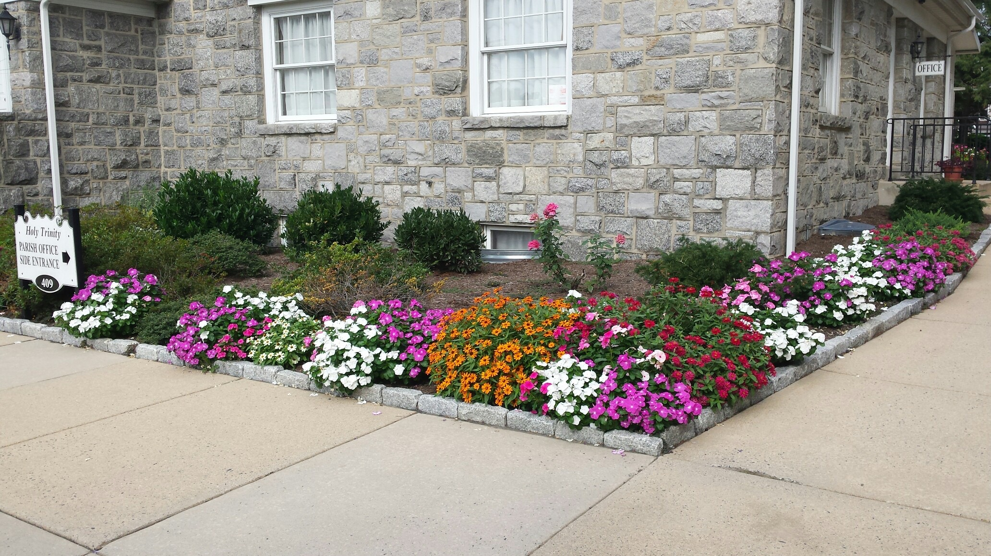
Brilliant hopes, all woven in gorgeous tissues,
Flaunting gayly in the golden light; Large desires, with most uncertain issues, Tender wishes, blossoming at night!

Big Cleaning Project Early In February

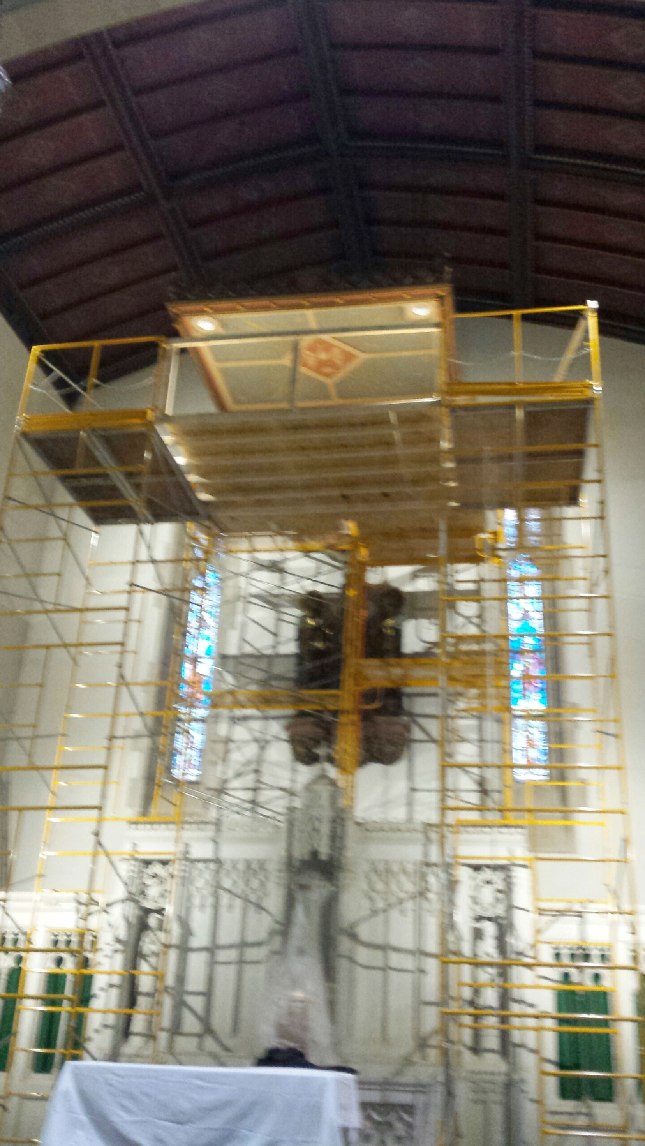
Late last fall and under the direction of Father Lawrence, the Building and Grounds Committee began searching for a company to fulfill our request to complete restoration work in the sanctuary of our church. We settled on Bahret Church Interiors, Inc. of Harrisburg, (www.bahretchurchinteriors.com), a reputable company that has completed extensive work on churches throughout the Mid-Atlantic States.
The Gothic wooden Crucifix with the statues of Mary and Saint John, along with the statues of the Good Shepherd and Blessed Mother, needed a once over. They were installed when the church was built. Hand carved and imported from Germany 89 years ago, the art work was long overdue for a cleaning and touchup with paint.
The Harrisburg firm worked with us scheduling the project after Christmas and before Lent. We didn’t want scaffolding to interfere with special services. Within six working days the work was completed. At the same time the company did an inspection on the structural soundness of the Canopy above the altar. It was installed circa 1947.

While work was being performed a number of parishioners wondered about the woman performing the tedious work. Her name is Julie Riker, a fine and decorative artist from Cumberland County, (www.julieriker.com). She graduated from Cumberland Valley High School and the University of the Arts.. After graduation she worked as a decorator in the historic restoration of the PA State Capitol, where she was involved for five years replicating original decorative painting, stenciling and applying gold leaf and ornamental plaster finishes.
She has traveled to New York, New Jersey, Maryland, and Virginia for commissioned projects. Also she has created and painted wall finishes for the PA Governor’s residence in 2002. Her work can also be seen at Gabriella Italian Restaurant and Saint Margaret Mary Catholic Church in Harrisburg, Saint James Catholic Church in Lititz, Sharon Lutheran Church in Selinsgrove and the Lebanon Country Club in Lebanon, PA. Now she can add Holy Trinity Catholic Church to her extensive resume.

